**📌 Day 1: Introduction to UI/UX Principles**

**summarizing UI/UX principles.**

1. **Simplicity**: Design should be easy to use and navigate.
2. **User-centered Design**: Focus on users' needs and preferences.
3. **Visibility**: Highlight important tasks clearly.
4. **Consistency**: Maintain consistent design elements.
5. **Feedback**: Provide feedback for users' actions.
6. **Clarity**: Prioritize clarity over visual appeal.
7. **Accessibility**: Ensure usability for everyone, including people with disabilities.
8. **Improved Usability**: Enhance user satisfaction and loyalty.
9. **Efficiency**: Optimize for speed and performance.
10. **Delight**: Create a positive emotional experience.

**Screenshots of 3 good & 3 bad UI/UX designs + 1-2 sentence explanations.**

**3 good UI/UX designs**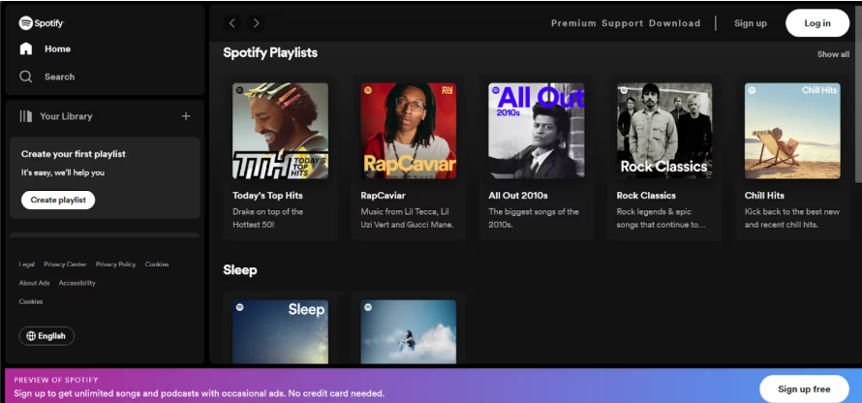

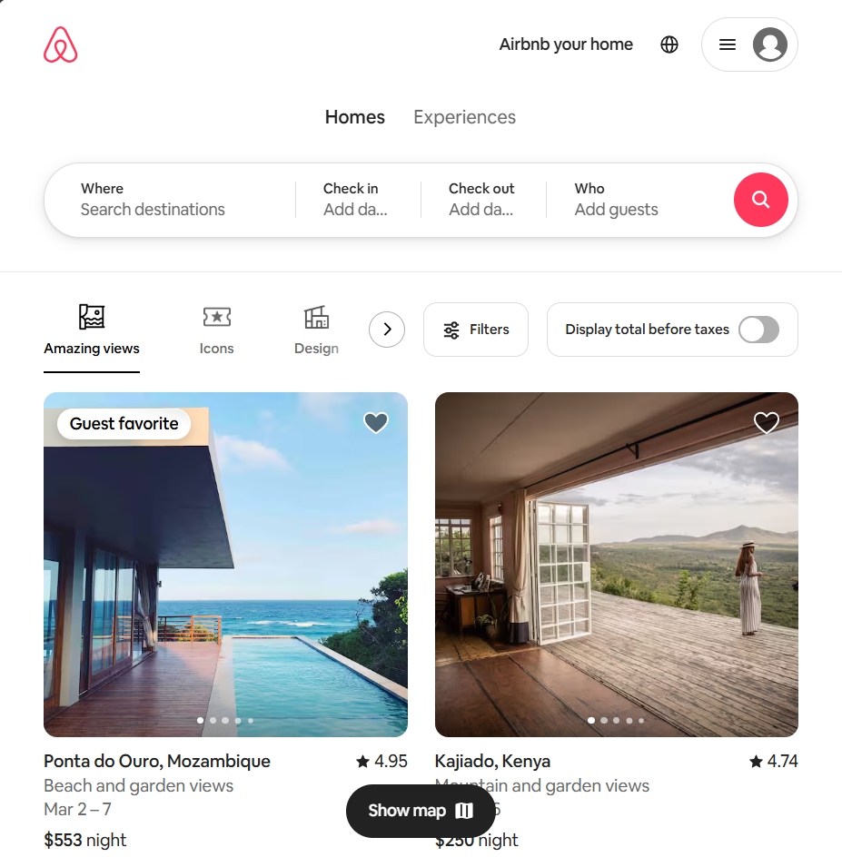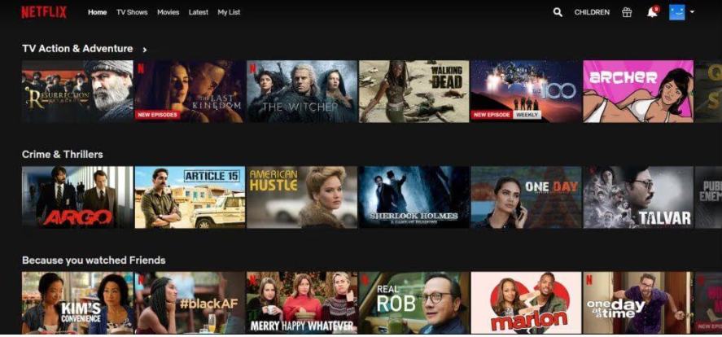

**3 good UI/UX designs**

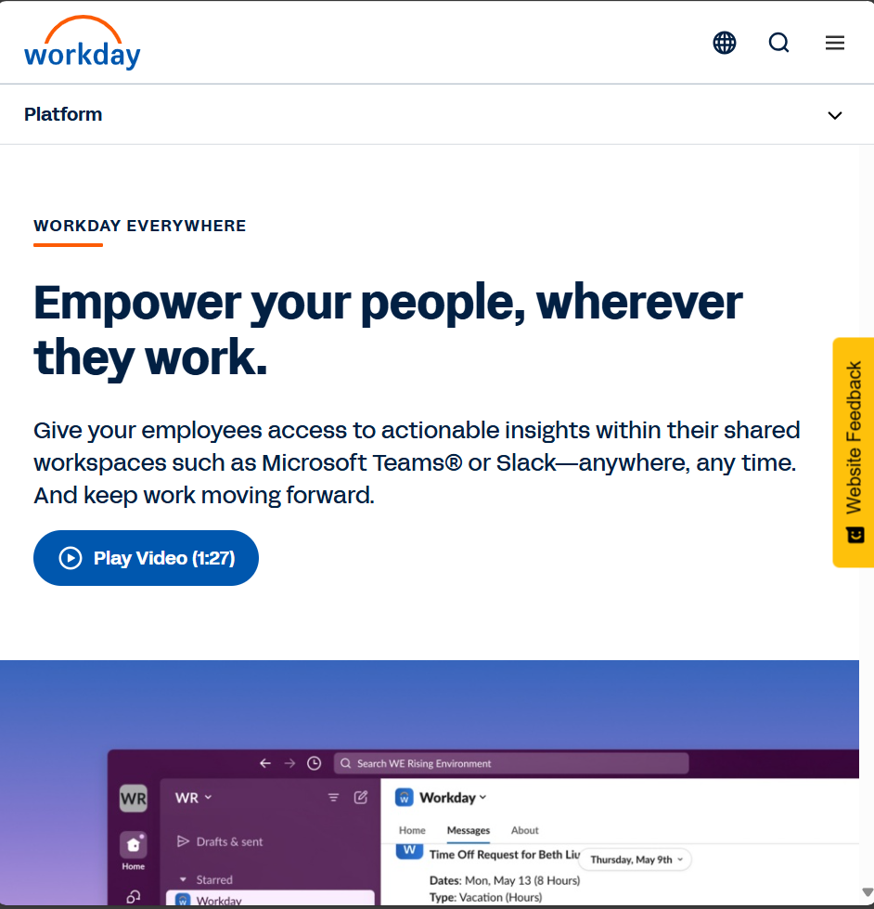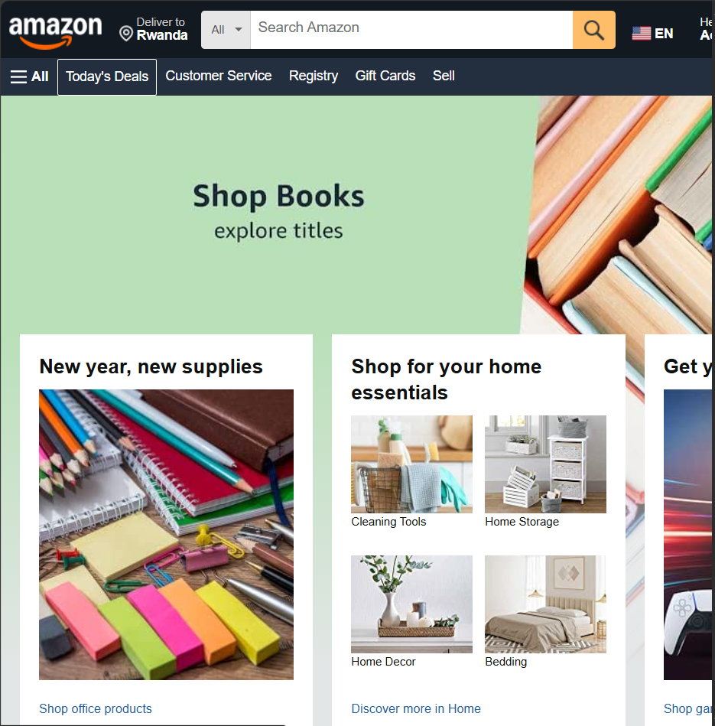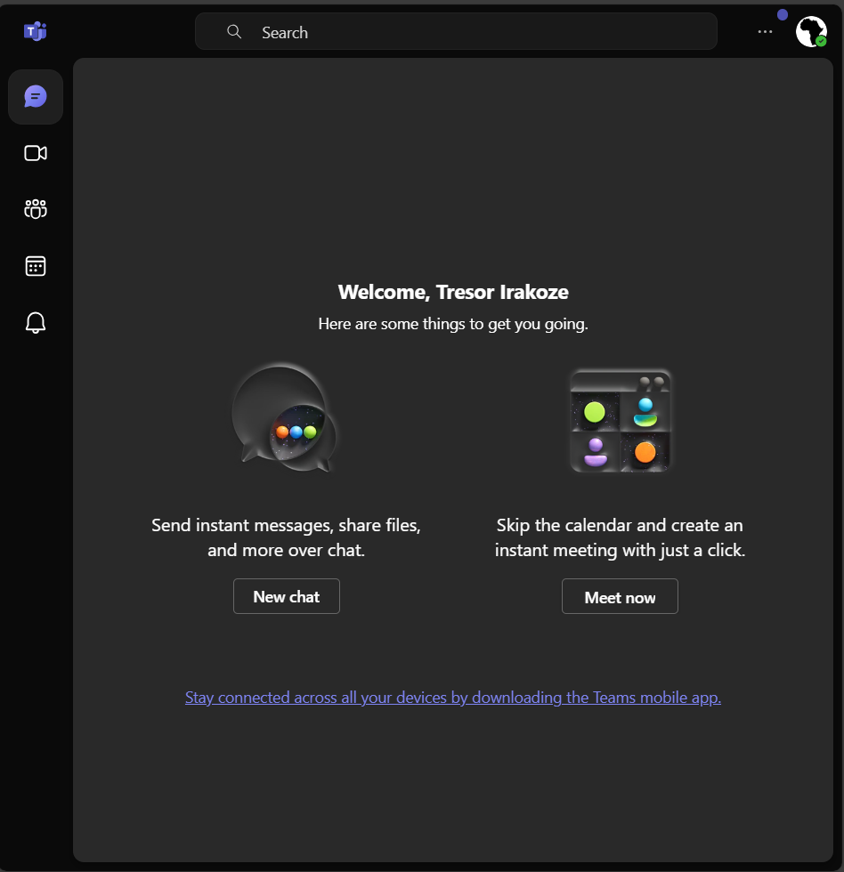

**Good UI/UX Design**

A good UI/UX design is intuitive and user-centric. It prioritizes simplicity and functionality, ensuring users can navigate and complete tasks effortlessly. Visual elements are consistent and aesthetically pleasing, while interactions are smooth and responsive, enhancing the overall user experience.

**Bad UI/UX Design**

A bad UI/UX design is confusing and frustrating for users. It often features cluttered layouts, inconsistent elements, and poor navigation, making it difficult for users to achieve their goals. Interactions may be unresponsive, leading to a negative experience and decreased user satisfaction.

**🎨 Day 2: Exploring Design Elements**

* A **brief explanation** of **color theory, typography, and responsive design**.

Typography is the art and technique of arranging type to make written language legible, readable, and appealing when displayed.

Color theory is the study of how colors interact with each other and how they evoke emotions and convey messages. In web design, color choices can influence user perception, brand identity, and overall aesthetic appeal.

Responsive design is an approach to web design in which the interface adapts to the device's layout to facilitate usability, navigation and information seeking.

* **A 1-2 paragraph analysis** of each UI/UX design (good & bad).

**Strengths and Weaknesses**

**Good UI/UX Designs**

1. **Airbnb**
   * **Strengths: User-friendly booking process, clean interface, and intuitive navigation.**
   * **Weaknesses: Some users might find the search filters overwhelming and the booking process lengthy.**

[**Airbnb | Vacation rentals, cabins, beach houses, & more**](https://www.airbnb.com/)

1. **Spotify**
   * **Strengths: Visually appealing and easy to use, dynamic content presentation, and excellent music discovery features.**
   * **Weaknesses: The free version has frequent ads, and the interface can be cluttered for new users.**

**https://open.spotify.com/**

1. **Netflix**

* **Strengths: Netflix offers a clean, intuitive interface with easy navigation, allowing users to effortlessly find and stream their favorite shows and movies. The platform also provides personalized recommendations based on viewing habits, enhancing user satisfaction.**
* **Weaknesses: Despite its strengths, Netflix's vast content library can sometimes make it difficult for users to discover new content, and the autoplay feature can be annoying for some users who prefer to browse without interruptions.**

**https://www.netflix.com/rw/**

**Bad UI/UX Designs**

1. **Workday**
   * **Strengths: Comprehensive functionality and wide range of features for HR and management.**
   * **Weaknesses: Cumbersome job application process, requiring repetitive manual entries, and a steep learning curve.**

[**Workday US Everywhere | Workday US**](https://www.workday.com/en-us/products/platform-product-extensions/workday-everywhere.html)

1. **Amazon**
   * **Strengths: Extensive product selection and powerful search capabilities.**
   * **Weaknesses: Cluttered product detail pages with inconsistent layout, overwhelming information, and complex navigation.**

[**Amazon.com. Spend less. Smile more.**](https://www.amazon.com/)

1. **Microsoft Teams**
   * **Strengths: Robust communication and collaboration features, integration with Microsoft Office Suite.**
   * **Weaknesses: Inconsistent UI elements, confusing navigation, and occasional performance issues.**

[**Chat | Microsoft Teams**](https://teams.live.com/v2/?tenantId=9188040d-6c67-4c5b-b112-36a304b66dad&login_hint=dontresor922%40gmail.com)

**📐 Day 3: Wireframing Basics**

✅ Sketch **low-fidelity wireframes** for **2 pages** of a web application.

📌 A **Figma link or image** of your wireframes.

[**https://www.figma.com/design/M83RAFyqSnPpLcCXKWaSPo/Untitled?node-id=1-2&t=etlg0dIhLwcIvVL3-1**](https://www.figma.com/design/M83RAFyqSnPpLcCXKWaSPo/Untitled?node-id=1-2&t=etlg0dIhLwcIvVL3-1)

**📌 A short explanation (2-3 sentences) of your design choices.**

A low fidelity with two pages where a user should search of that web application using the url and being redirected to the home where he/she has an account or not and on the home page there is an option of Login and then when you click it, it redirects you on the Login page.

**🎨 Day 4: High-Fidelity Design**

**https://www.figma.com/design/xATiQWp1vqnGslop7H9wa8/High-Fidelity?node-id=0-1&t=CYUzsuHiNUnVdxf7-1**